Intake Form Session 1

Client Name: _____________________________________________
Session #1 Date: __________________

Injuries: _____________________________________________________________________

Movement restrictions: ________________________________________________________

Surgeries: ____________________________________________________________________

Any Pain (scale of 1-10): 1 2 3 4 5 6 7 8 9 10

Location of Pain: ______________________________________________________________

Medications: __________________________________________________________________

Diet: _________________________________________________________________________

Supplements/herbs: ____________________________________________________________

Allergies: ____________________________________________________________________

Blood pressure: ___________________________ Heart disease: ______________________

Varicose veins: _______________________________________________________________

Pregnancy: ___________________________________________________________________

Sleeping rhythm: ______________________________________________________________

Psychological/Emotional/Stress: __________________________________________________

Yoga practice: _________________________________________________________________

Meditation practice: ____________________________________________________________

Energy Level (scale of 1-10): (Low) 1 2 3 4 5 6 7 8 9 10 (High)

Main goal / Results desired: _____________________________________________________

______________________________________________________________________________

A – Assessment- Please circle areas of discomfort and blocked energy

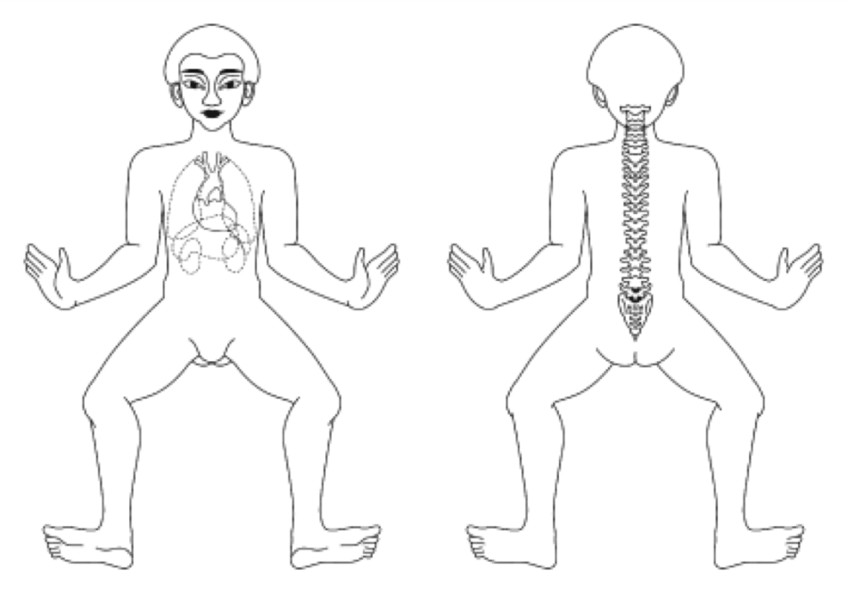

Thank you! The rest is for my use…

P - Procedure: Sequences performed (check all that apply):
___ Single Foot ___ Double Foot ___ Leg Lines (Supine) ___ Level 1 Leg Work ___Level 2 Leg Work
___ Abdominal ___ Side Lying ___ Arms ___ Prone ___ Inverted ___ Seated ___ Relaxation
___ Mind Clearing (L1) ___ Chakra Balancing (L2)
OTHER: _______________________________________________________________________________

E - Evaluation:

Notes for self for next time:

